**Pandemic Emergency Status Declaration**

**First Renewal Form | 31-60 Days in Stage 3**

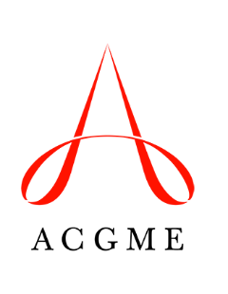

|  |
| --- |
| *Email completed and signed forms to* [*dio@acgme.org*](mailto:dio@acgme.org)*. The ACGME will contact the designated institutional official (DIO) with any questions and will send confirmation of renewal of Pandemic Emergency Status declaration to the DIO and institutional coordinator.* |

1. Sponsoring Institution Name

|  |
| --- |
|  |

1. ACGME 10-Digit ID

|  |
| --- |
|  |

1. Designated Institutional Official Name

|  |
| --- |
|  |

1. What is the term of the Sponsoring Institution’s renewed declaration of Pandemic Emergency Status?

30 days  Less than 30 days (please specify) .

1. The Sponsoring Institution may exempt programs from this declaration only if those exempted programs have no participating sites in common with other programs that are subject to this declaration. If the Sponsoring Institution wishes to exempt programs from this declaration, list the programs to be exempted and their participating sites. (The exempted programs would be outside the area affected by Stage 3 conditions.) Add rows as needed.

|  |  |  |
| --- | --- | --- |
| **Specialty/Subspecialty** | **ACGME ID** | **Participating Site(s)** |
|  |  |  |
|  |  |  |

*By signing the Pandemic Emergency Status Declaration Form, the designated institutional official:*

* *requests that the Sponsoring Institution and its ACGME-accredited program(s) be granted a renewal of Pandemic Emergency Status through the ACGME’s Extraordinary Circumstances policy;*
* *attests that this request for renewal of Pandemic Emergency Status has been approved by the clinical leadership of the primary clinical site(s) of the Sponsoring Institution’s accredited program(s);*
* *attests that all voting members of the Sponsoring Institution’s Graduate Medical Education Committee have been informed in writing of this request for renewal; and,*
* *attests that the Sponsoring Institution will ensure that its ACGME-accredited programs are compliant with specified ACGME Common Program Requirements that protect residents/fellows, health care teams, and patients throughout the term of the Pandemic Emergency Status declaration, as described in* [*Stage 3: Pandemic Emergency Status Guidance*](https://acgme.org/COVID-19/Stage-3-Pandemic-Emergency-Status-Guidance)*.*

__________________________________________ __________________

Designated Institutional Official Signature Date